Withu247 Report
Team :
Ritik Kumar Gola (02816401522)
Anjitesh Shandilya (02016401522)

Problem Statement:

In an era marked by fragmented mental health resources, individuals struggle to access comprehensive support. Existing platforms lack integration, accessibility, and reliability, leaving many feeling isolated. A one-stop mental health website is imperative, offering seamless access to therapy, counseling, medication management, and support services to empower users effectively.
Objectives:
1. Enhance Accessibility: Ensure easy and immediate access to mental health resources anytime, anywhere, catering to diverse user needs and schedules.
2. Integrated Support: Provide a seamless platform offering therapy, journaling tools, medical consultations, and prescription management for comprehensive mental health care.
3. Professional Guidance: Connect users with licensed therapists and medical professionals for personalized support and guidance throughout their mental health journey.
4. User Empowerment: Equip individuals with tools and resources to actively manage their mental well-being, fostering a sense of control and agency in their health care.
5. Community Engagement: Foster a supportive online community where users can share experiences, offer encouragement, and access peer support, promoting a sense of belonging and reducing feelings of isolation.

Solution:
Introducing "with247": a pioneering one-stop mental health website addressing the challenges of fragmented care. Offering integrated services including therapy, journaling tools, medical consultations, and prescription management, it ensures comprehensive support. Users benefit from seamless access, fostering holistic well-being and empowering individuals to prioritize and maintain mental health effectively.
AIM: SELECTING BEST-FIT SDLC MODEL
Model:
In Agile software development, the process is typically broken down into iterative and incremental steps. Here's a simplified overview of the Agile model steps:
1. Project Initiation: Define the project vision, objectives, and scope. Create a high-level plan and assemble the agile team.
2. Requirement Analysis: Gather and prioritize requirements in collaboration with stakeholders. Create user stories or other artifacts to capture requirements.
3. Iteration Planning: Break down the requirements into smaller tasks or user stories. Estimate the effort required for each task and select the ones to be completed in the upcoming iteration.
4. Development: Implement the selected tasks or user stories according to the requirements. Developers work collaboratively in short iterations, typically lasting 1-4 weeks.
5. Daily Stand-ups: Hold brief daily meetings (stand-ups) to discuss progress, challenges, and plans for the day. This keeps the team aligned and enables quick problem-solving.
6. Integration and Testing: Developers continuously integrate their code into a shared repository. Automated tests are run to ensure that new code changes do not break existing functionality.
7. Review and Adaptation: At the end of each iteration, conduct a review or demo of the completed work. Collect feedback from stakeholders and team members. Reflect on what went well and what could be improved, and adapt the process accordingly.
8. Release and Deployment: Once the iteration goals are met and the product increment is deemed shippable, deploy it to the production environment or release it to users.

9. Feedback and Iteration: Gather feedback from users and stakeholders after each release. Use this feedback to inform future iterations and prioritize the backlog for upcoming work.
10. Continuous Improvement: Continuously refine and improve the Agile process based on lessons learned, changing requirements, and feedback from stakeholders. Embrace a culture of continuous learning and adaptation.
These steps are repeated in subsequent iterations, with each iteration adding new features or enhancements to the product. The Agile model emphasizes flexibility, collaboration, and delivering value to customers in short cycles.
User Interfaces:
1. “Withu247” app for ios and android.
2. “Withu247” website for all platform.

User Case Diagram:

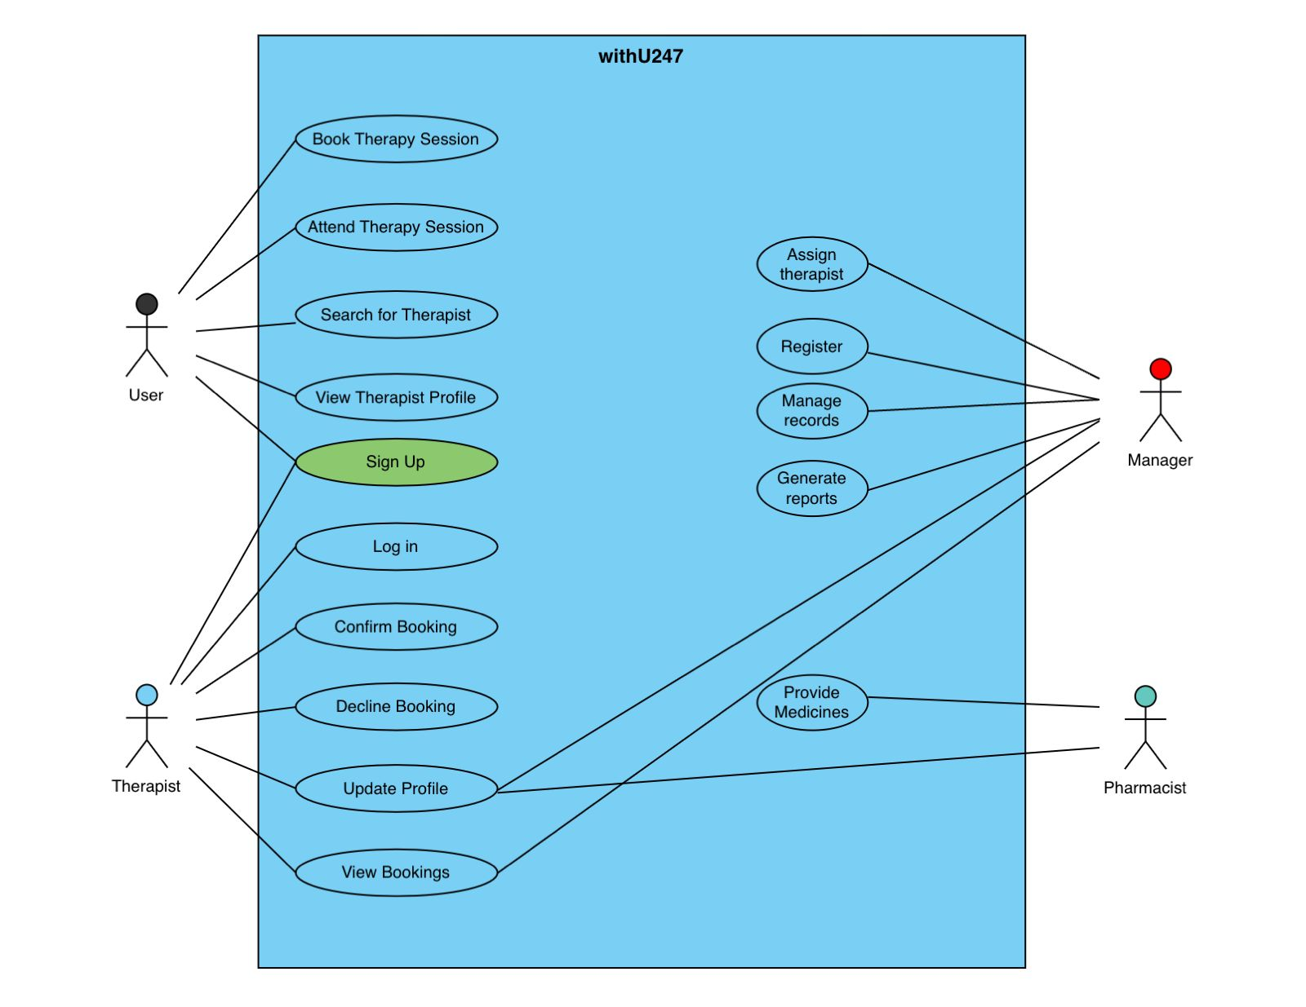

Software Requirements Specification (SRS) for "WithU247" Mental Health

1. Introduction

"WithU247" is a mental health website aimed at providing comprehensive support and resources for individuals seeking assistance with mental health issues. The platform integrates features such as journaling, medicine ordering, and therapy to facilitate users in managing their mental well-being effectively.

2. Purpose

The purpose of "WithU247" is to offer a user-friendly platform where individuals can access various mental health services conveniently. By providing features like journaling, medicine ordering, and therapy, the website aims to empower users to take proactive steps towards improving their mental health.

3. Scope

"WithU247" will include the following core features:

- Journaling: Users can maintain a private journal to record their thoughts, feelings, and experiences.
- Medicine Ordering: Users can order prescription medications related to mental health conditions through the website.
- Therapy: Users can connect with licensed therapists for online therapy sessions or counseling.

4. Functional Requirements

4.1 Journaling

- Users can create an account and log in to access the journaling feature.
- Upon logging in, users can create new journal entries, edit existing entries, and delete entries.
- Entries can be categorized by date, mood, or customizable tags for easy organization.
- Users have the option to keep their journal entries private or share them with selected contacts or therapists.

4.2 Medicine Ordering

- Users must provide necessary personal and medical information during the registration process.
- Users can search for prescribed medications related to mental health conditions.
- The website should provide detailed information about each medication, including dosage, side effects, and usage instructions.
- Users can add medications to their cart and proceed to checkout for payment and delivery.

4.3 Therapy

- Users can browse a directory of licensed therapists available for online therapy sessions.
- Users can filter therapists based on specialization, availability, and other criteria.
- Users can schedule appointments with their chosen therapist and receive confirmation notifications.
- The website should facilitate secure video conferencing or messaging for online therapy sessions.

5. Non-functional Requirements

5.1 Security

- User data, including journal entries and medical information, must be encrypted and stored securely.
- The website should implement user authentication and authorization mechanisms to ensure only authorized users can access sensitive information.
- Payment transactions for medicine ordering should be processed through secure and trusted payment gateways.

5.2 Performance

- The website should be responsive and provide a seamless user experience across different devices and screen sizes.
- Response times for loading pages and processing user requests should be minimal to enhance user satisfaction.

5.3 Scalability

- The website architecture should be designed to accommodate a growing user base and increased traffic.
- Infrastructure resources should be scalable to handle spikes in usage without compromising performance.

6. User Interfaces

- The user interface should be intuitive and easy to navigate, with clear instructions for accessing and utilizing each feature.
- Visual elements should be aesthetically pleasing and conducive to a positive user experience.

7. Constraints

- Compliance with applicable laws and regulations related to healthcare data privacy and security, such as HIPAA (Health Insurance Portability and Accountability Act) in the United States.
- Integration with third-party services for medication ordering and payment processing, ensuring compliance with their APIs and terms of service.

8. Hardware Requirements:

8.1. Server:
- Processor: Dual-core or higher
- RAM: 8 GB or more
- Storage: SSD recommended for faster data access
- Bandwidth: High-speed internet connection to handle user requests

8.2. Database Server:
- Consideration for a separate server for the database management system (DBMS)
- Adequate storage for user data and system backups

8.3. Network Infrastructure:
- Reliable network equipment to ensure seamless communication between servers and users
- Load balancing mechanisms for handling traffic spikes

9.Software Requirements:

9.1. Operating System:
- Web Server: Linux (e.g., Ubuntu, CentOS) or Windows Server
- Database Server: Compatible with the chosen DBMS (e.g., MySQL, PostgreSQL)

9.2. Web Server:
- Apache, Nginx, or another web server for hosting the website

9.3. Database Management System (DBMS):
- MySQL, PostgreSQL, or another relational database system

9.4. Programming Languages:
- Server-Side: Node.js, Python, Ruby on Rails, or other suitable languages
- Client-Side: HTML5, CSS3, JavaScript (React, Angular, or Vue.js)

9.5. Frameworks and Libraries:
- Utilize appropriate frameworks and libraries based on the chosen programming languages
- Example: Express.js for Node.js, Django for Python

9.6. Security:
- SSL certificate for secure data transmission (HTTPS)
- Regular security audits and updates
- Implementation of secure coding practices

9.7. Content Delivery Network (CDN):
- Integration with a CDN for efficient content delivery to users worldwide

9.8. Monitoring and Analytics:
- Implementation of monitoring tools for performance tracking
- Integration with analytics tools for user behavior analysis

9.9. Collaboration and Communication Tools:
- Integration with communication tools for support and counseling sessions
- Secure messaging systems

9.10. Backup and Recovery:
- Regular automated backups of the database and system
- Procedures for disaster recovery

9.11. Compliance and Regulations:
- Adherence to health data privacy regulations (e.g., HIPAA)
- Accessibility standards for a diverse user base

9.12. Mobile Responsiveness:
- Ensure the website is responsive to different devices, particularly mobile devices

9.13. User Authentication and Authorization:
- Secure user authentication mechanisms
- Role-based access control for different user types

9.14. Scalability:
- Architecture designed for scalability to handle potential growth in user numbers

9.15. Integration:
- Ability to integrate with external services (e.g., payment gateways, health record systems)

9.16. Testing and Quality Assurance:
- Comprehensive testing strategy, including unit testing, integration testing, and user acceptance testing

9.17. Documentation:
- Detailed system documentation for maintenance and future development

9.18. Legal and Ethical Considerations:
- Adherence to legal and ethical standards in mental health service delivery

Write a program to estimate metrics of a project
- Function points
- Basic COCOMO model
- Intermediate COCOMO model

Source Code:
#include <iostream>
#include <cmath>
using namespace std;

// Function to estimate Function Points
int calculateFunctionPoints(int inputs, int outputs, int inquiries, int files, int interfaces) {
int fp = 4 * (inputs + outputs + inquiries + files + interfaces);
return fp;
}

// Function to estimate Basic COCOMO model
void calculateBasicCocomo(int SLOC, double &effort, double &time, double &staff) {
effort = 2.4 * pow(SLOC, 1.05);
time = 2.5 * pow(effort, 0.38);
staff = effort / time;
}

// Function to estimate Intermediate COCOMO model
void calculateIntermediateCocomo(int SLOC, const string& mode, double &effort, double &time, double &staff) {
double a, b, c, d;
if (mode == "organic") {
a = 2.4; b = 1.05; c = 2.5; d = 0.38;
} else if (mode == "semi-detached") {
a = 3.0; b = 1.12; c = 2.5; d = 0.35;
} else if (mode == "embedded") {
a = 3.6; b = 1.20; c = 2.5; d = 0.32;
} else {
cout << "Invalid mode. Choose from 'organic', 'semi-detached', or 'embedded'." << endl;
return;
}
effort = a * pow(SLOC, b);
time = c * pow(effort, d);
staff = effort / time;
}

int main() {
int inputs, outputs, inquiries, files, interfaces, SLOC;
string intermediateMode;

// User input
cout << "Enter number of inputs: ";
cin >> inputs;
cout << "Enter number of outputs: ";
cin >> outputs;
cout << "Enter number of inquiries: ";
cin >> inquiries;
cout << "Enter number of files: ";
cin >> files;
cout << "Enter number of interfaces: ";
cin >> interfaces;
cout << "Enter source lines of code (SLOC): ";
cin >> SLOC;
cout << "Enter mode for Intermediate COCOMO (organic/semi-detached/embedded): ";
cin >> intermediateMode;

// Calculate metrics
int functionPoints = calculateFunctionPoints(inputs, outputs, inquiries, files, interfaces);
double basicEffort, basicTime, basicStaff;
calculateBasicCocomo(SLOC, basicEffort, basicTime, basicStaff);
double intermediateEffort, intermediateTime, intermediateStaff;
calculateIntermediateCocomo(SLOC, intermediateMode, intermediateEffort, intermediateTime, intermediateStaff);

// Display results
cout << "\nFunction Points: " << functionPoints << endl;
cout << "Basic COCOMO (Effort, Time, Staff): " << basicEffort << ", " << basicTime << ", " << basicStaff << endl;
cout << "Intermediate COCOMO (Effort, Time, Staff): " << intermediateEffort << ", " << intermediateTime << ", " << intermediateStaff << endl;

return 0;
}

Output:

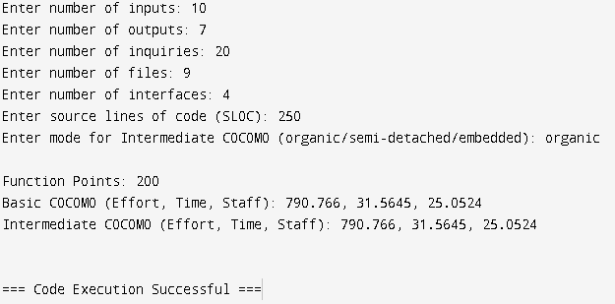

DATA FLOW DIAGRAM
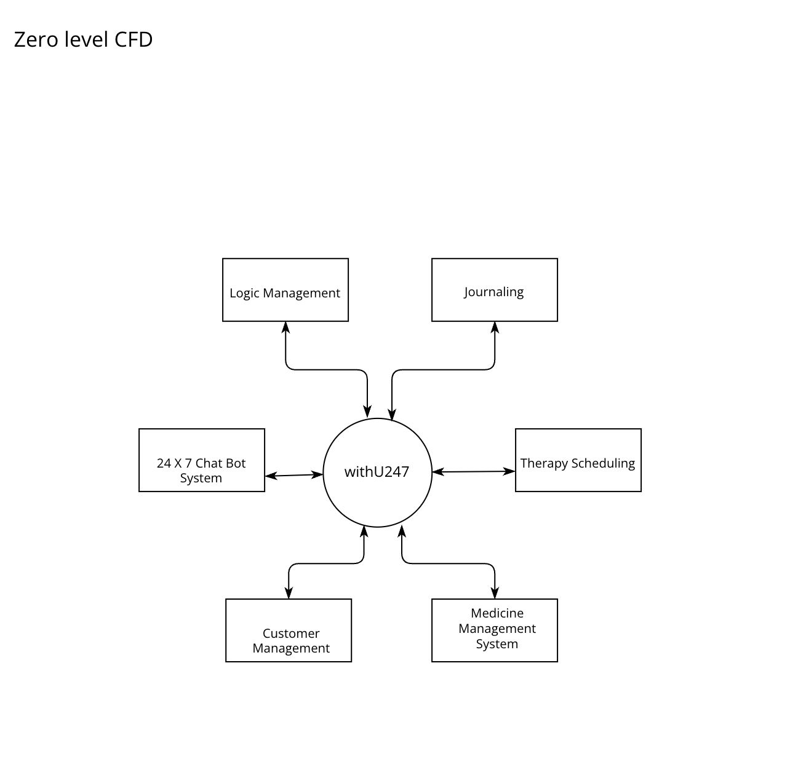
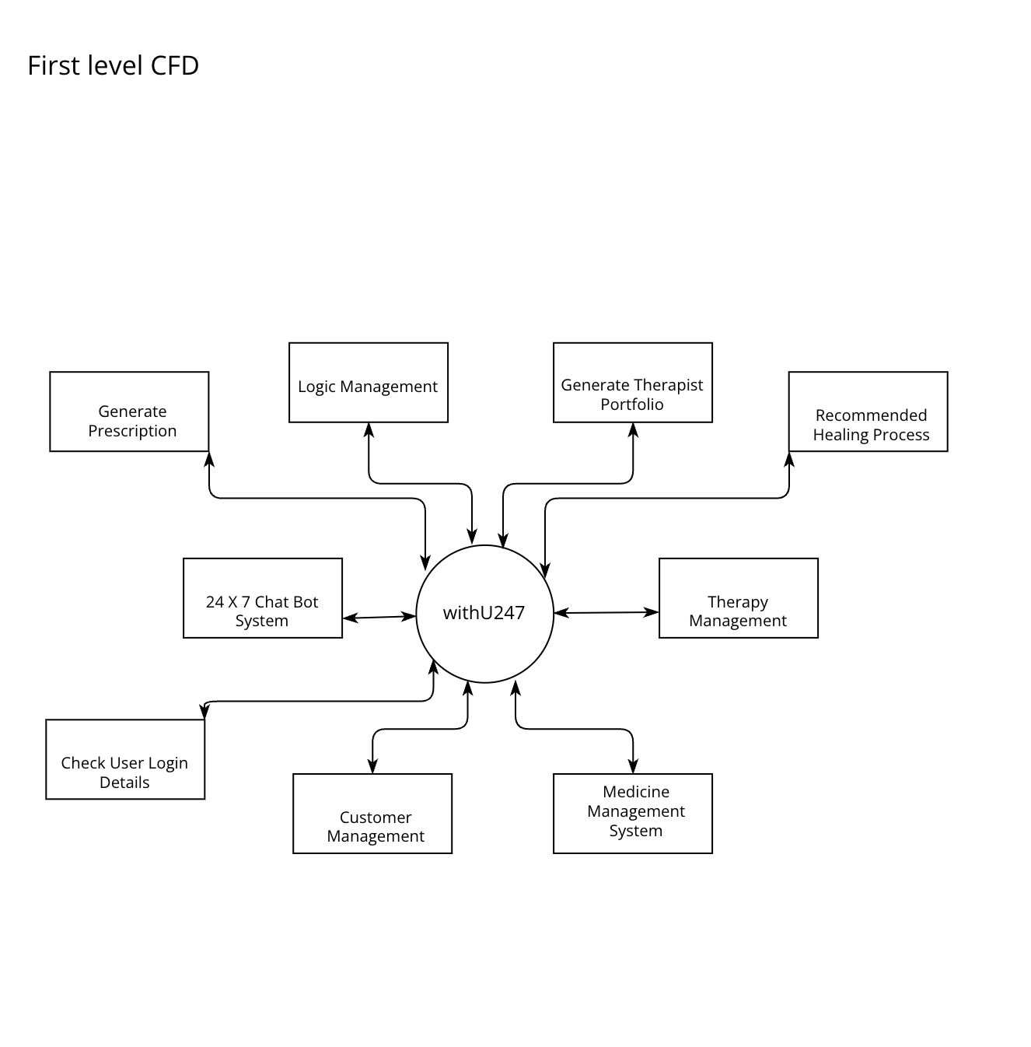
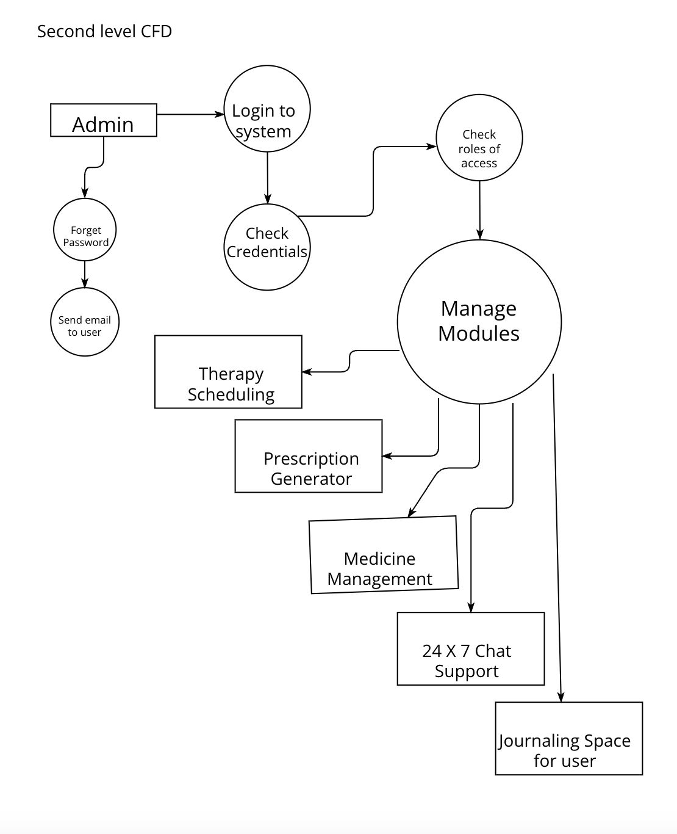

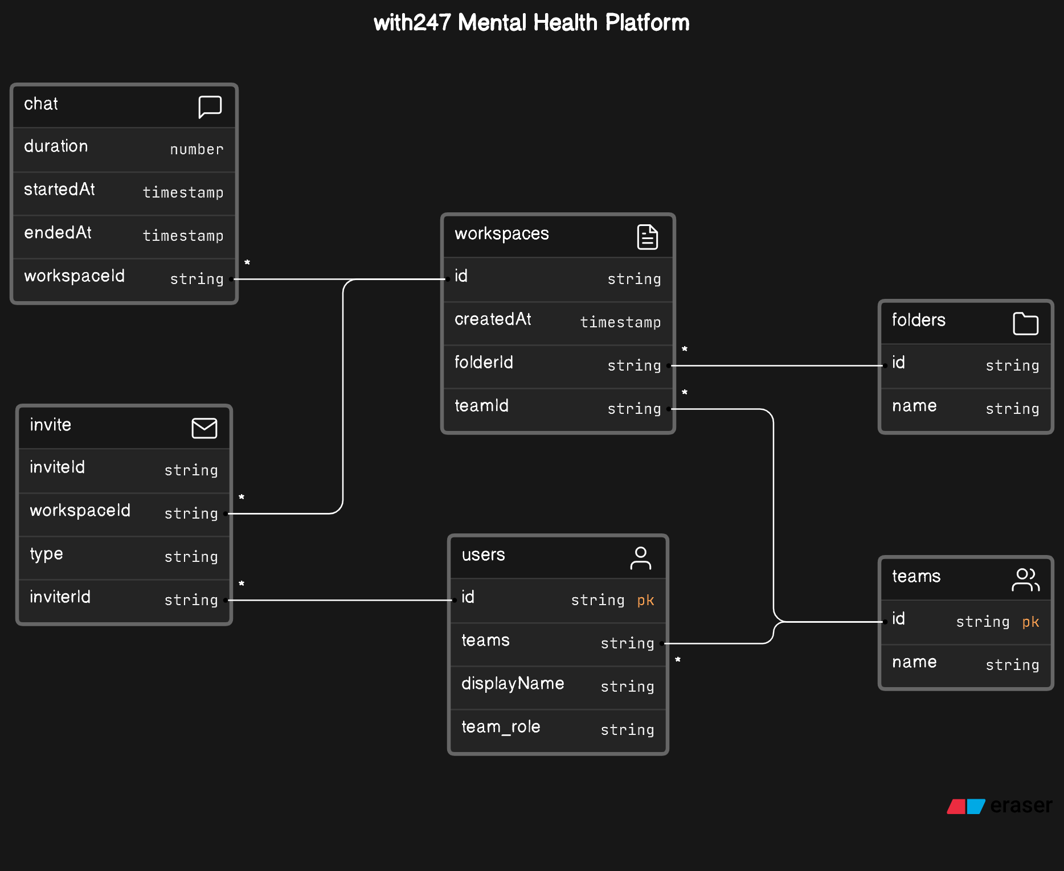

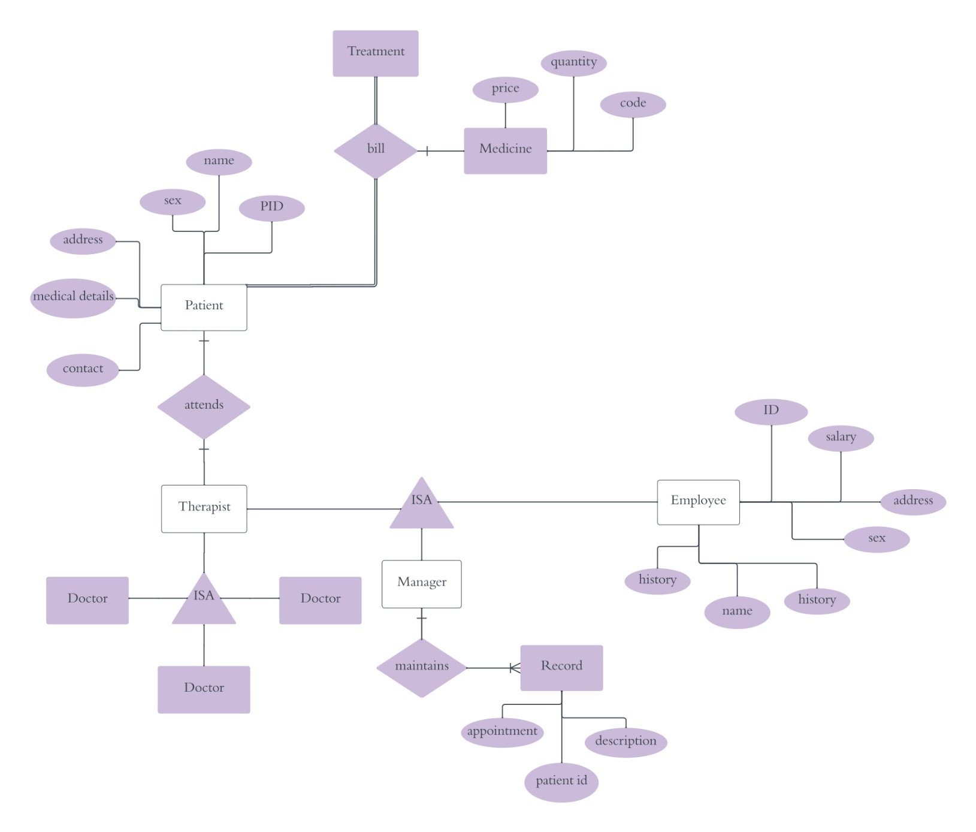

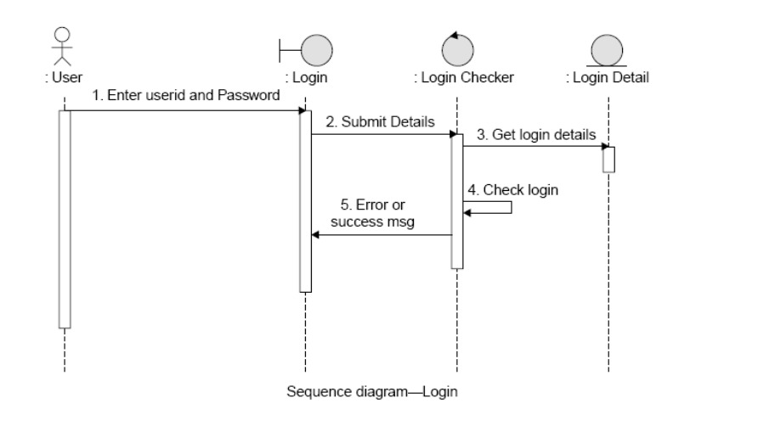

PROGRAM:
Write a program to compute cyclomatic complexity of any program.
#include <iostream> #include <fstream> #include <string> #include <regex>

using namespace std;

class CyclomaticComplexityCalculator {
private:
int numRegions; // Variable to store cyclomatic complexity

// Helper function to count occurrences of a substring in a string
int countSubstringOccurrences(const string& str, const string& sub) {
int count = 0;
size_t pos = 0;
while ((pos = str.find(sub, pos)) != string::npos) {
count++;
pos += sub.length(); }
return count; }

public:
CyclomaticComplexityCalculator() : numRegions(1) {} // Initialize to 1 for the main method

// Function to read code from a file
void readCodeFromFile(const string& filename) {
ifstream file(filename);
string line;
while (getline(file, line)) {
// Count the number of control structures in each line
numRegions += countSubstringOccurrences(line, "if");
numRegions += countSubstringOccurrences(line, "while");
numRegions += countSubstringOccurrences(line, "for");
numRegions += countSubstringOccurrences(line, "switch");
// Add 1 for each occurrence of a logical OR or AND operator
numRegions += countSubstringOccurrences(line, "||");
numRegions += countSubstringOccurrences(line, "&&");
// Add 1 for each occurrence of a ternary operator
numRegions += countSubstringOccurrences(line, "?"); } }
// Function to calculate and display cyclomatic complexity
void displayCyclomaticComplexity() {
cout << "Cyclomatic Complexity: " << numRegions << endl; }};

int main() {
CyclomaticComplexityCalculator calculator;

string filename;
cout << "Enter the filename of the program to compute cyclomatic complexity: ";
cin >> filename;

calculator.readCodeFromFile(filename);
calculator.displayCyclomaticComplexity();

return 0;}

OUTPUT-

